 | 12.1.51 Editors - Geometry Nodes Editor - Header - Add Menu - Utilities - Rotation
Table of content
Detailed table of content 1
Add menu - Utilities - Rotation 4
Align Rotation to Vector 4
Axes to rotation 5
Axis Angle to Rotation 5
Euler to Rotation 6
Invert Rotation 6
Mix Rotation 7
Rotate Rotation 7
Rotate Vector 8
Rotation to Axis Angle 8
Rotation Euler 9
Rotation to Quaternion 9
Quaternion to Rotation 9

Detailed table of content
Detailed table of content
Detailed table of content 1
Add menu - Utilities - Rotation 4
Align Rotation to Vector 4
Inputs 4
Rotation 4
Factor 4
Vector 4
Properties 4
Align Axis 4
Pivot 4
Output 5
Rotation 5
Axes to rotation 5
Inputs 5
Primary Axis 5
Secondary Axis 5
Properties 5
Primary axis 5
Secondary Axis 5
Output 5
Rotation 5
Axis Angle to Rotation 5
Inputs 5
Axis 5
Angle 6
Output 6
Rotation 6
Euler to Rotation 6
Inputs 6
Euler 6
Output 6
Rotation 6
Invert Rotation 6
Inputs 6
Rotation 6
Output 6
Rotation 6
Mix Rotation 7
Inputs 7
Factor 7
A, B 7
Properties 7
Data Type 7
Outputs 7
Rotation 7
Rotate Rotation 7
Inputs 7
Rotation 7
Rotate By 7
Properties 7
Rotate Space 7
Global 7
Local 8
Outputs 8
Rotation 8
Rotate Vector 8
Inputs 8
Vector 8
Rotation 8
Output 8
Rotation 8
Rotation to Axis Angle 8
Inputs 8
Rotation 8
Output 8
Axis 8
Angle 8
Rotation Euler 9
Inputs 9
Rotation 9
Output 9
Euler 9
Rotation to Quaternion 9
Inputs 9
Rotation 9
Output 9
W, X, Y, Z 9
Quaternion to Rotation 9
Inputs 9
W, X, Y, Z 9
Output 10
Rotation 10

Add menu - Utilities - Rotation
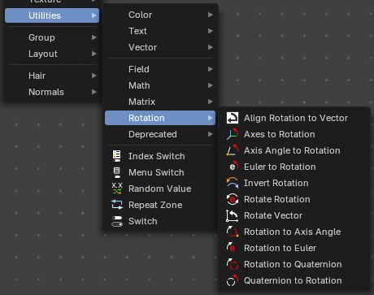
Utility nodes are mainly for mathematical operations.

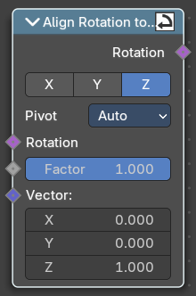
Align Rotation to Vector
Aligns a rotation to a vector.

Inputs

Rotation
The input euler rotation vector.

Factor
The factor to align the euler value to the vector.

Vector
The vector to align to.

Properties

Align Axis
To which axis to align the vector.

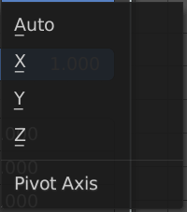
Pivot
The pivot axis.

Output

Rotation
The output rotation euler angle.

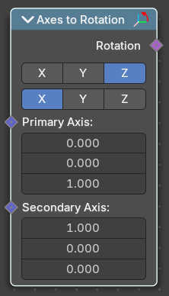
Axes to rotation
Creates a rotation from a primary and a secondary axis. The axis should be ideally orthogonal.

Inputs

Primary Axis
The axis to rotate around.

Secondary Axis
The secondary axis that gives the alignment.

Properties

Primary axis
Which axis to rotate around.

Secondary Axis
Which axis to align to.

Output

Rotation
The output rotation euler angle.

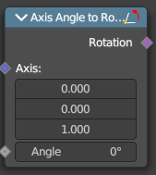
Axis Angle to Rotation
Converts an axis angle to a rotation.

Inputs

Axis
The input axis.

Angle
The input angle.

Output

Rotation
The output rotation value.

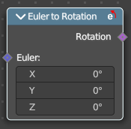
Euler to Rotation
Converts an euler angle to a rotation.

Inputs

Euler
The input euler angle vector.

Output

Rotation
The output rotation value.

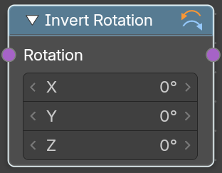
Invert Rotation
Inverts a rotation

Inputs

Rotation
The input rotation vector.

Output

Rotation
The output rotation value.

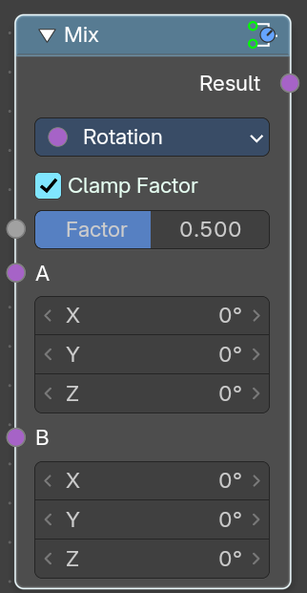
Mix Rotation
Rotates an euler rotation by another euler rotation.

Inputs

Factor
amount of mixing between a and b inputs.

A, B
The input.

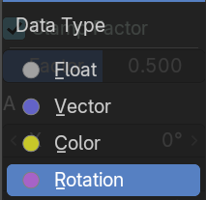
Properties

Data Type
What data to calculate.

Outputs

Rotation
The euler angle output.

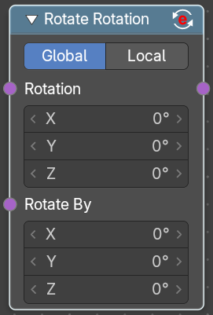
Rotate Rotation
Rotates an euler rotation by another euler rotation.

Inputs

Rotation
Use the rotation of an existing geometry.

Rotate By
The input rotation.

Properties

Rotate Space

Global
Rotate by the global orientation

Local
Rotate by the local orientation

Outputs

Rotation
The euler angle output.

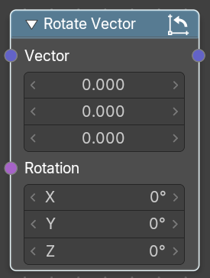
Rotate Vector
Rotates a vector.

Inputs

Vector
The input vector.

Rotation
The input rotation.

Output

Rotation
The output rotation value.

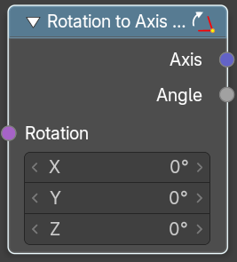
Rotation to Axis Angle
Converts a rotation vector to axis angle.

Inputs

Rotation
The input vector.

Output

Axis
The axis output.

Angle
The angle output.

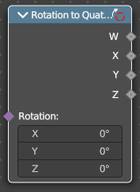
Rotation Euler
Converts a rotation vector to an euler angle.

Inputs

Rotation
The input vector.

Output

Euler
The euler angle.

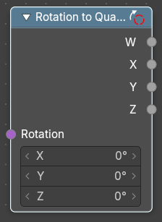
Rotation to Quaternion
Converts a quaternion to a rotation vector.

Inputs

Rotation
The input vector.

Output

W, X, Y, Z
The single output values of the quaternion.

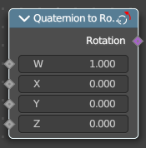
Quaternion to Rotation
Converts a rotation vector to a quaternion.

Inputs

W, X, Y, Z
The single input values of the quaternion.

Output

Rotation
The output rotation.

